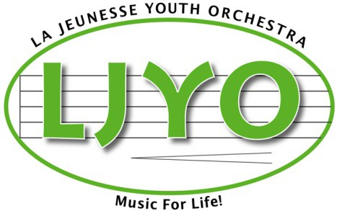

Member’s Name

INFORMATION AND COMMUNICATION RELEASE

Yes No I give permission for my LJYO member, name and photograph to be included in items such as the following: Orchestra Website, Newsletter, Brochure, slideshow, Video and other promotional material.
Yes No I give permission for the news media to interview my LJYO member, publish or broadcast photos or videos of my child, and/or publicize my member’s work.
Yes No I understand that my LJYO member may be photographed or videotaped by others in the course of events associated with the LJYO.
Yes No I give my permission for my name, phone number and email address to be shared with LJYO for all communication purposes.
Yes No Canada’s anti-spam legislation (CASL) prevents La Jeunesse Youth Orchestra Inc. from sending any electronic messages which are commercial in nature without your consent. Examples of commercial messages includes invitations to purchase group photographs, LJYO merchandise, special events and field trips etc. these may be direct messages or could be included in newsletters. I give consent to receive commercial electronic messages for these purposes from La Jeunesse Youth Orchestra and Foundation.

Yes No If you agree and consent, please provide your email address in the space below.
Your consent to receive these messages can be revoked at any time by contacting the Orchestra manager.

Parent/Guardian Comments: _________________________________________________________

Signature: __________________________________________________________________________

Email Address: ______________________________________________________________________

