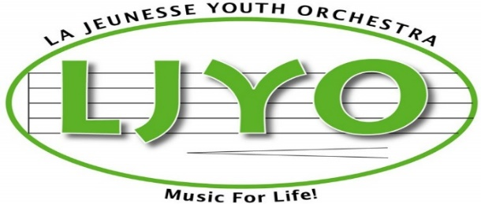

Assumption of Risk and Waiver of Liability Relating to COVID-19

This waiver & declaration must be completed prior to or upon visiting La Jeunesse Youth Orchestra and before participating in Season 23.

The novel coronavirus, COVID-19 has been declared a worldwide pandemic by the World Health Organization. COVID-19 is extremely contagious and is known to spread mainly by contact from person to person. Consequently, Local, Provincial and Federal governmental authorities recommend various measures and prohibit a variety of behaviors, in order to reduce the spread of the virus.

La Jeunesse Youth orchestra Inc. and its members commit themselves to comply with the requirements and recommendations of National, Provincial and local Public health and other governmental authorities, and to put in place and adopt all necessary measures to that effect. However, La Jeunesse Youth Orchestra Inc. cannot guarantee that your child will not become infected with COVID-19. Further, attending the activities could increase your child’s risk of contracting COVID-19, despite all preventative measures put in place. La Jeunesse Youth Orchestra Inc. supports the use of the COVID Alert mobile app by all members.
____________________________________________________________________________
By signing this document,
- I acknowledge the highly contagious nature of COVID-19 and I voluntarily assume the risk that my child could be exposed to or infected by COVID-19 by participating in La Jeunesse Youth Orchestra’s activities. Being exposed or infected by COVID-19 may lead to injuries, diseases or other illnesses.

- I declare that my child is participating voluntarily in La Jeunesse Youth Orchestra’s in-person activities.

- I hereby agree that I must inform the La Jeunesse Youth Orchestra Manager or Executive Committee if my child was ill in the 14 days prior to an in-person rehearsal or becomes ill during the 14 days following an in-person rehearsal and will not attend if they are ill. I agree that my child will in case of illness, agree to attend virtual rehearsals until physically recovered to return according to Public Health guidance.

- I agree that I will support my child to perform a self-assessment for symptoms of or exposure to COVID-19 prior to participating in any in-person activities and to permit La Jeunesse Youth Orchestra Inc. to maintain a record of their self-assessment throughout Season 23 and for three months following the end of the season.

- I declare that neither my child nor anyone in my household or social circle, have experienced cold or flu-like symptoms in the last 14 days (including fever, cough, sore throat, respiratory illness, difficulty breathing).

- If my child or anyone in my household or social circle experiences any cold or flu-like symptoms, my child will not attend the La Jeunesse Youth Orchestra’s in-person activities or programs until at least 14 days have passed since those symptoms were last experienced. I agree that my child will attend virtual rehearsals instead until physically recovered to return according to Public Health guidelines.

- Neither my child nor any member of my household has travelled to or had a lay-over in any country outside Canada, or in any Province outside of Ontario, in the past 14 days. If my child travel, or if anyone in my household travels after submitting this declaration, my child will not attend the in-person rehearsals, programs and activities of La Jeunesse Youth Orchestra’s until at least 14 days have passed since the date of return. I agree that my child will attend virtual rehearsals until able to return according to Public Health guidelines.

- My child and I agree to adhere to the requirements and recommendations of National, Provincial and local Public health and other governmental authorities and to those safety regulations put in place by La Jeunesse Youth Orchestra Inc. as pertaining to COVID-19.

- I, and my child agree that, by filling out and signing this waiver and agreeing to the terms and conditions set out herein, I am giving up my legal rights to sue La Jeunesse Youth Orchestra Inc. and its officers and directors, in the event that my child become infected with COVID-19 and becomes ill as a result and/or transmits the virus to another person.

- In addition to releasing LJYO, I also indemnify LJYO from liability as a result of my child’s actions.

This document will remain in effect until La Jeunesse Youth Orchestra Inc. as per the direction of the National, Provincial and Local government health officials, determine that the acknowledgments in this declaration are no longer required.
This document is in addition to and does not replace all other La Jeunesse Youth Orchestra Inc. waivers.

I HAVE SIGNED THIS DOCUMENT FREELY AND WITH FULL KNOWLEDGE.
I acknowledge that I have been advised that I have the right to obtain independent legal advice, and I waive that option.
______________________________ __________________________________
Name of member (print) Name of parent (print)

______________________________ __________________________________
Signature of member Signature of parent

Place/Date: ___________________________________________________________
Approved by LJYO Board – Sept. 2021

